**Mrs. Phillips Syllabus**

[**mphillips@chickasawschools.com**](mailto:mphillips@chickasawschools.com)

**Urgent Information**

Please ensure you read this syllabus carefully. It is the **full responsibility of the student** to know when items are due and to ensure they make up any work they have missed for any reason (Students have 3 DAYS). Grades are updated weekly. Parents can contact the office for their login so they can monitor their students’ grades online and can also see any missing grades. **THE NATURE OF THIS CLASS IS CAREER PREP AND STUDENTS WILL BE EXPECTED TO BEHAVE IN A PROFESSIONAL MANNER. WE HAVE EXPENSIVE EQUIPMENT & ITEMS THAT CAN CAUSE INJURY. STUDENTS WILL BE WRITTEN UP AND REMOVED FROM CLASS IF THEY ARE NOT ABLE TO FOLLOW EXPECTATIONS, RULES AND DIRECTIONS.**

**All work & class information is available online at** [**https://chickasaw.schoology.com/**](https://chickasaw.schoology.com/)

**Materials Needed**

**Student Supplies (required)**

**It is the responsibility of each student to be prepared for class**. Most assignments will be completed online so students need to make sure they know all of their information or have it written down somewhere safe! Random notebook checks will be graded to ensure students are taking notes, their notebooks are their study guides and it is important that they use them and study them often.

* Spiral Notebook
* Pencils or Pins
* Pencil sharpener with case
* School Email Address (@chickasawschools.com) & Password
* Username & Password for all programs

**Course Description**

AP Computer Science Principles is an introductory college-level computing course that introduces students to the breadth of the field of computer science. Students learn to design and evaluate solutions and to apply computer science to solve problems through the development of algorithms and programs. They incorporate abstraction into programs and use data to discover new knowledge. Students also explain how computing innovations and computing systems—including the internet—work, explore their potential impacts, and contribute to a computing culture that is collaborative and ethical.

Computer Science Discoveries (CS Discoveries) is an introductory computer science course appropriate for 6th - 10th grade students. The curriculum emphasizes problem-solving, creation, and collaboration, while introducing students to the many ways computer science impacts their lives.

Exploring Computer Science is a year-long, research-based, high school intro-level computer science curriculum. Exploring Computer Science is a high school introduction to the world of computer science and problem solving. It is a yearlong course consisting of 6 units, approximately 6 weeks each.

The We Build It Better program lays a foundation for students to understand the process of developing a new product and equipping them with the skills to design and create an innovative solution to a real-world industry-based challenge. Is the program engineering, manufacturing, computer science? It is ALL of that and more! It is an all-inclusive 18-week, industry-designed educator-developed, curricular experience that engages middle school students in a work-like STEAM environment.

**Attendance & Tardies**

See school wide policies and procedures.

Missed Work: **IT IS THE JOB OF THE STUDENT TO TURN IN WORK AND GET THE WORK THEY MISSED. EVERYTHING IS POSTED ON SCHOOLOGY.**

**Grades**

Grades are updated weekly. Parents and Students can track their grades, missed work and upcoming assignments online, please contact the front office for information about your parent login. Students will have **3 DAYS** to turn in work after missing class or an assignment due date. After that students will get a zero.

**Expectations**

Students are expected to follow classroom policies for their safety and the safety of the equipment.

**Students and/or parents may be held liable if students do not follow policies and expectations that result in the damage of property.**

1. NO food or drink allowed in the lab at any time.
2. NO sprays or sticky items such as perfume, spray deodorant or slime.
3. Students must remain seated at their assigned computer.
4. NO physical contact of any kind.
5. NO running or horseplay in the lab.
6. NO unapproved games or VPNs (unblocked games).
7. All chats and technology use is monitored at all times.
8. Students must ensure their personal belongings are not a tripping hazard.
9. Students will NOT access any social media or take any video/pictures without teacher permission.
10. Students will NOT use anyone else’s login.
11. Students will NOT use personal headphones/earbuds.
12. Students will NOT have a cell phone or personal device in sight. (must be in your **backpack** or they will be taken & given to an administrator!)
13. Students will follow all school expectations, rules and procedures.
14. Students will take responsibility for their education.
15. Students are responsible for making up their own work within 3 Days. Everything is available online for them.
16. Students will NOT write on or intentionally damage mouse pads, tables or anything that does not personally belong to them.

**Required AP dates for APCSP:**

AP Study Sessions (HS) October 18 4-6 pm

AP Study Sessions (HS) November 10 7-9 pm

AP Study Sessions (HS) January 4 10am-Noon

AP Study Sessions (HS) February 28 4-6 pm

AP Study Sessions (HS) April 6 7-9 pm

AP Palooza (Off Campus) April 22 all day

May 8 AP EXAM DAY

**Tribe Time**

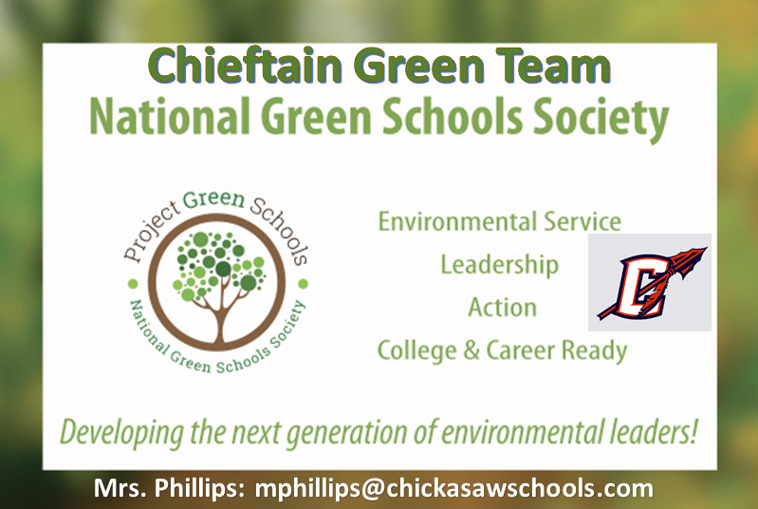

**Students can earn special Graduation Attire by actively participating in our Chieftain Green Team. TSA is a competitive technology club where students can learn leadership skills.**

**We will meet weekly and *attendance is taken*.**

**.**

**PLEASE SIGN AND RETURN THIS PAGE!**

**We have thoroughly read & understood Mrs. Phillips’ Syllabus. I have kept the syllabus at home for reference but know that I can also access it online all year. We agree to abide by the information in the syllabus. I understand Mrs. Phillips will use School Status for my contact information, so it should be updated with the front office anytime it changes (phone numbers). I understand Mrs. Phillips updates grades weekly and I can monitor my student’s progress online. I understand it is my student’s responsibility to turn in work, including if they are absent. I give my student permission to watch the videos/movies in class and to be videoed and/or photographed. I understand that the email and accounts provided belong to the school and will be monitored even if used or accessed at home. I will speak with my child about the responsibility of taking care of the equipment that belongs to the school and I understand if my child damages the equipment I could be held financially responsible. This includes, but is not limited to, software, mouse pads, keyboards, monitors, computers, laptops, mice, tables, chairs and anything else that belongs to the school or Mrs. Phillips.**

Student’s Name (print): _______________________________________________________Period: _________

***Student’s Signature: _______________________________________________________________________***

Guardian Name (print): ______________________________________________________________________

***Guardian Signature: ________________________________________________________________________***

***Please list any allergies, restrictions on videos/movies, special needs or anything else you would like me to know about your child.***